**TITLE OF THE PAPER**

**Full Name SURNAME*, Full Name SURNAME\*\***

*Faculty, Department, University, University full address  
**Faculty, Department, University, University full address

author_1 e-mail, author_2 e-mail

*received ……., revised ……., accepted …….*

# Abstract: In this place, there should be a summary typewritten in Arial Narrow, 9 pts., single spacing: 0 pts before, 36 pts after. 1cm double-sided and centered indents. The abstract should include elements such as background, objective, methods, results and conclusions. The abstract should be clear, descriptive, self-explanatory and not longer than 200-300 words.. Please do not use mathematical formulas in the abstract.

# Key words:

1. **INTRODUCTION**

To write an article for publishing in Acta Mechanica et Automatica use Microsoft Word for Windows and save your file in .docx format [1].

Page numbering: Arial Narrow 9 pts., page margins.

Hyphenation: automatic (Fig. 1).

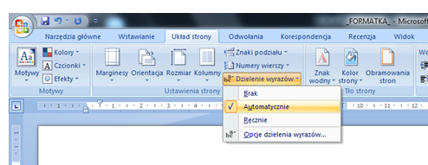

**Fig. 1.** Hyphenation - automatic

Odd Page Header: *Acta Mechanica et Automatica, vol.x no.x (xxxx)*  – Arial Narrow 8 pts., italic, underlined, right-aligned, single spacing: before 0 pts., after 12 pts. [2].

Even Page Header: Author_1name, Author_2 name, Title of article – Arial Narrow 8 pts., italic, underlined, left-aligned, single spacing: before 0 pts., after 12 pts.

Titles of chapters: Arial Narrow 10 pts., bold, single spacing: before 18 pts., after 18 pts.

Guidelines for the introduction and abstract:

* title of the article: Arial Narrow 12 pts. bold, single spacing: before 48 pts., after 0 pts.;
* names of authors: Arial Narrow 10 pts. bold, single spacing: before 18 pts., after 18 pts.;
* chair, department, university, university address: Arial Narrow 9 pts. sigle spacing: before 0 pts., after 0 pts.;
* authors’ e-mail addresses: Arial Narrow 9 pts. underlined, single spacing: before 12 pts., after 12 pts.

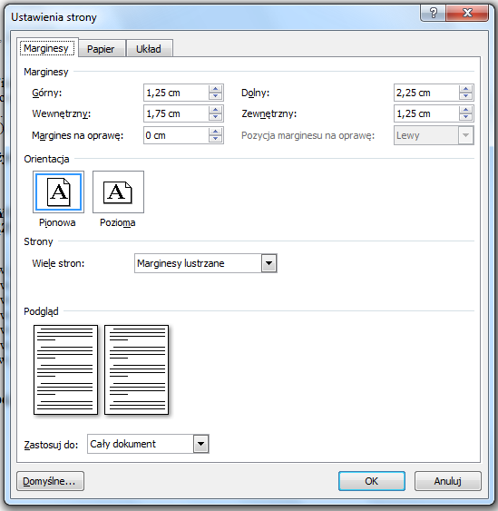

**Fig. 2.** Page set-up – margins

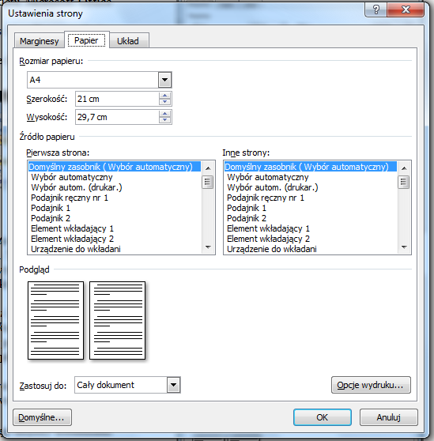

**Fig. 3.** Page set-up – paper

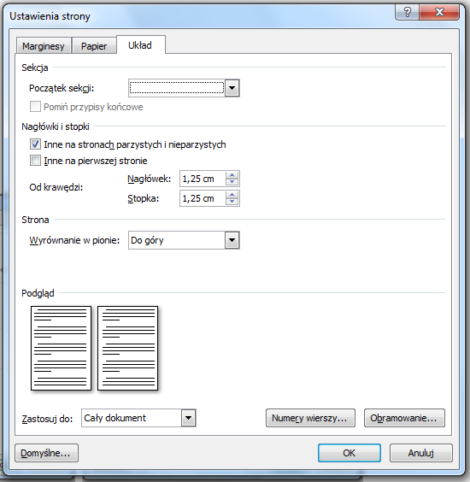

**Fig. 4.** Page set-up – layout

With the exception of introduction and abstract, the whole document should be prepared in two-column format [3]:

* format – A4 (21 x 29.7 cm);
* column width – 8.5 cm; spacing between columns – 1 cm (single spacing);
* font: Arial Narrow – 10 pts., normal;
* article text style – standard;
* alignment – two-sided;
* paragraph format – the first line of 0.5 cm;
* for binding – 0 cm;
* mirror margins: internal – 1.75 cm, outer – 1.25 cm, upper – 1.25 cm, bottom – 2.25 cm;
* header – 1.25 cm;
* footer – 1.25 cm.

General settings are given in Figs. 2 – 4.

1. **CHAPTER TITLE**

The article should be submitted by sending it through the system at https://www.editorialmanager.com/ama/.

Each author and co-author should also deliver to the editorial office a signed copyright transfer statement (original by mail, scan/pdf by e-mail or fax to +48 85 746 92 10)

* 1. **Section title**

Numbering styles more complex than the XX should be avoided. The titles of sections should be in Arial Narrow   
10 pts., bold, single spacing: before 18 pts., after 18 pts.

* 1. **Drawings, diagrams, graphs, tables**

Drawings, diagrams and tables should be clear, made of black lines on a white background, centred in the column. When placing drawings in colour, please note that they are in colour only on the web site of the journal, whereas the printout will be in black and white. Drawings, diagrams and graphs shall be denoted as Fig. X.

Width of the figure should not exceed the width of a column (8.5 cm), spacing: before 18 pts., after 0 pts. In case of broader drawings, it is advisable to place them by closing the division into columns in a given place (Fig. 6).

The text should include references to figures and tables (e.g., "... in Fig. 1," "... in Tab. 1"). All descriptions in the drawing area should be typed with the font of not more than 9 pts.

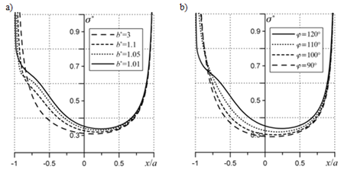

**Fig. 5.** Contact pressure distribution: a) gap distance effect;   
 b) gap orientation effect

Drawing captions should be typed in Arial Narrow 9 pts., single spacing: before 3 pts., after 18 pts [4]. When using one description to several drawings, the drawings shall be denoted in the sequence: a), b), etc. Letters a), b) should be within the figure), with the description as shown in Fig. 5.

**Tab. 1.** Table name

|  |  |  |  |
| --- | --- | --- | --- |
| **tekst** | **tekst** | **tekst** | **tekst** |
| tekst | tekst | tekst | tekst |
| tekst | tekst | tekst | tekst |
| tekst | tekst | tekst | tekst |

Tables and figures should be placed in portrait orientation. The thickness of lines in tables should be ½ point. For tables larger than the column act as in the case of extensive drawings.

Text in the table should be in Arial Narrow – 9 pts., single pacing: before 1 point, after 1 point (in special cases it is possible to use a smaller font without reducing the readability of the table).

Captions above the tables should be done in Arial Narrow 9 pts., single spacing: before 18 pts., after 3 pts. In the text directly under the table, use the line spacing above 18 pts [5].

* 1. **Mathematical formulas**

Mathematical formulas should be type written in mathematical style, aligned to left and numbered irrespective of chapter numbering.

Fonts used in formulas:

* mathematical symbols (e.g. sin, lg) – Cambrai Math 9 pts., straight;
* variables – Cambria Math 9 poits, italic;
* indices (lower/upper) variables (e.g. *ij* in *σij*) – italic font 8 pts.;
* indices (lower/upper) constants (after original names, e.g. 1 in *σ*1) – straight font 8 pts.;
* indices (lower/upper) dependent constants and variables as above, font 6 pts.;
* vectors and matrices – straight, bold font 10 pts.;
* intervals: before 6 pts., after 6 pts., single spacing

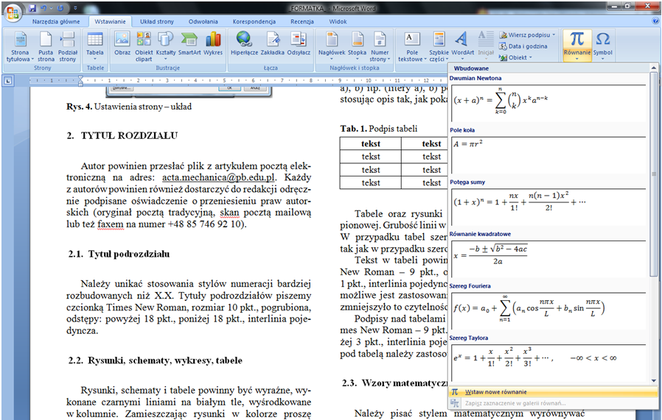

**Fig. 6.** Inserting formulas

Numbers of formulas typed in standard text format should be placed in parentheses and aligned to right of the edge of a given column, as below:

${\left(x+a\right)}^{n}=\sum_{k=0}^{n}{\left({n \atop k}\right)x^{k}a^{n-k}}$ (1)

where: $x$– description, $a$– description, $a^{n-k}$– description, $\left({n \atop k}\right)$  
– description.

The formulas, both numbered and those in the text should be type written as shown in Fig. 6 (so that they do not increase the line spacing).

SI units must be consistently applied in the text.

**REFERENCES**

List of the literature should be typed in Arial Narrow – 9 pts., alphabetical order is not required. Please use Vancouver style [6].

1. Korbut M, Szpica D. A Review of Compressed Air Engine in the Vehicle Propulsion System. Acta Mechanica et Automatica. 2021;15(4): 215-226. https://doi.org/10.2478/ama-2021-0028
2. Cherepova T, Dmitrieva G, Tisov O, Dukhota O, Kindrachuk M. Research on the Properties of Co-Tic and Ni-Tic Hip-Sintered Alloys. Acta Mechanica et Automatica. 2019;13(1): 57-67.

https://doi.org/10.2478/ama-2019-0009

1. Pears R, Shields G. Cite them right: the essential referencing guide. Palgrave study skills. 10th ed. Basingstoke: Palgrave; 2016.
2. Kanneganti P, Harris JD, Brophy RH, Carey JL, Lattermann C, Flanigan DC. The effect of smoking on ligament and cartilage surgery in the knee: a systematic review. Am J Sports Med [Internet]. 2012 Dec [cited 2019 Feb 19];40(12):2872-8. Available from: http://ajs.sagepub.com/content/40/12/2872

doi: 10.1177/0363546512458223

1. Simons NE, Menzies B, Matthews M. A Short Course in Soil and Rock Slope Engineering. London: Thomas Telford Publishing; 2001.
2. Yevtushenko A, Topczewska K, Zamojski P. Influence of Thermal Sensitivity of Functionally Graded Materials on Temperature during Braking. Materials [Internet]. 2022 Jan 26;15(3):963. Available from: http://dx.doi.org/10.3390/ma15030963

Any acknowledgments and notes should be at the end of the article   
(9 pts.) Such as: "The work has been accomplished under the research project No. 7 T07C 006 12 financed by the Scientific Research Committee".

Author's 1 name:  https://orcid.org/

Author's 2 name:  https://orcid.org/